

School of Sciences and Engineering

Department of Computer Science and Engineering

Spring 2022

Senior Project 1

**Software Design Document [SDD]**

**G6 - “Classroom Monitoring Using AI”**

Supervised By:

Dr. Sherif Aly

Dr. [Hesham Eraqi](mailto:heraqi@aucegypt.edu)

Table of Contents

1. Introduction

1.1 Purpose

1.2 Document conventions

1.3 Intended audience

1.4 Contact information/SDD team members

2. System Overview

2.1 Background Information

2.2 Constraints

2.3 Design Trade-offs

2.4 User Characteristics

3. System Architecture

3.1 Hardware Architecture

3.2 Software Architecture

3.3 Communication Architecture

4. Data Design

4.1 Database Management System Files

4.2 Non-Database Management System Files

5. Detailed Design

5.1 Hardware Detailed Design

5.2 Software Detailed Design (With a design of each component).

5.3 Communication Detailed Design

6. Interfacing with External Systems

7. Usability Design Approach

8. Glossary of Terms

* **Introduction:**
* 1.1 Purpose:

The purpose of the Software Design Document is to describe and highlight the software specifications of our senior project titled “Classroom Monitoring Using AI” and how it is expected to operate and function. The document will illustrate a detailed technical overview of the software/hardware architecture of the software.

The scope of this project is to create a safe and fair examination environment for students that eliminates the high rates of cheating during examinations in Egypt. Consequently, violating academic integrity creates a critical issue that negatively affects the reputation of the national education system, the quality, and competence of graduates.

* 1.2 Document Conventions:

This document was created based on the IEEE (IEEE Standard 1016-2009) template for System Requirement Specification Documents.

* 1.3 Intended Audience:

This Software Design Document is to describe and highlight a detailed technical overview of the software/hardware architecture of the software. The document is mainly intended to be written for the developers of the “Classroom Monitoring Using AI” project and for future references for the users of this project.

* 1.4 Contact information/SDD team members:

In case you have any inquiries or questions regarding this Software Design Document, below are the contact details for the project/SRS team members:

- Noha Abdelkader

Undergraduate Computer Engineering Student

The American University in Cairo

[noha.alshabrawy@aucegypt.edu](mailto:noha.alshabrawy@aucegypt.edu)

- Marwan Amr Awad

Undergraduate Computer Engineering Student

The American University in Cairo

[marwanawad@aucegypt.edu](mailto:marwanawad@aucegypt.edu)

- [Mohamed Elsayed Gamil Elshabshiri](mailto:elshabshiri@aucegypt.edu)

Undergraduate Computer Engineering Student

The American University in Cairo

[elshabshiri@aucegypt.edu](mailto:elshabshiri@aucegypt.edu)

-[Mohamed Ashraf Taha](mailto:mohammedashraf@aucegypt.edu)

Undergraduate Computer Engineering Student

The American University in Cairo

[mohammedashraf@aucegypt.edu](mailto:mohammedashraf@aucegypt.edu)

-[Omar Sherif Elmahdy](mailto:omarmahdy122@aucegypt.edu)

Undergraduate Computer Engineering Student

The American University in Cairo

[omarmahdy122@aucegypt.edu](mailto:omarmahdy122@aucegypt.edu)

- [Youssef Khaled Beshir](mailto:youssefbeshir@aucegypt.edu)

Undergraduate Computer Engineering Student

The American University in Cairo

[youssefbeshir@aucegypt.edu](mailto:youssefbeshir@aucegypt.edu)

* **System Overview:**

2.1 Background Information:

Our project will be used as a tool to help proctors detect cheating cases in exams, specifically Thanawiya Amma. This is achieved by installing a security camera in the classrooms and feeding the output video to a software model we developed using deep learning techniques. The model classifies human beings in the classroom into one of several classes: non-cheating, cheating by phone, passing cheat sheets, standing(in case of a proctor), etc. If a suspected cheating case is detected, a notification is sent to the proctor to track the suspected case.

2.2 Constraints:

→ Camera type, fps

→ Position at which camera is put -- no blind spots

2.3 Design trade-offs:

The input image for the detection model is very large so it trades off the speed of the prediction of the model for accuracy.

2.4 User Characteristics:

System users should be qualified and approved by the Ministry of Education to deal with such a product. This is because of the sensitive information exposed in the video recordings.

* **System Architecture:**

3.1 Hardware Architecture:

The diagram below shows an illustration of the hardware architecture of the system. The system mainly consists of the IP camera that is positioned in the center of the classroom to capture the classroom top view to have a good view of the classroom environment.

Another main component in the system is the computing node of the system, which is the computer that would be placed in the classroom to compute and process the data generated by the camera. In addition to, alerting the user about any possible cheating incidents via the software.

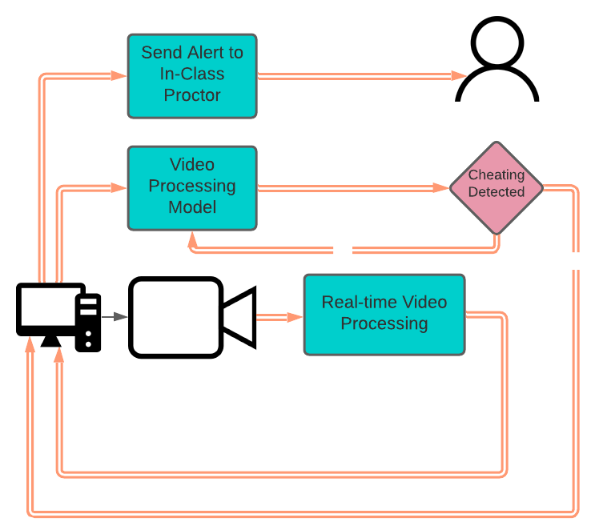

3.2 Software Architecture:

The system could be divided into 3 main blocks. The first one includes the hardware setup, including the camera and PC, and the deep learning model. The second block is the backend including 2 servers: EC2 is the primary one while Heroku is the backup, that host the central database and Flask APIs. The last block of the project is the frontend, where the user interacts with the software. The frontend has been developed using ElectronJS which uses web technologies, such as HTML5, CSS3, JavaScript, and Bootstrap to develop cross-platform desktop applications that can be run on different operating systems platforms, such as macOS, Micorsoft Windows, and Linux.

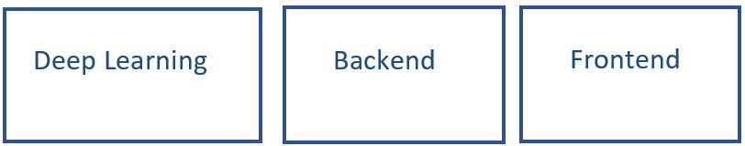

3.3 Communication Architecture:

The following diagram illustrates the communciton between the system nodes and how the data flow is being operated between the system backend, deep learning model, and frontend.

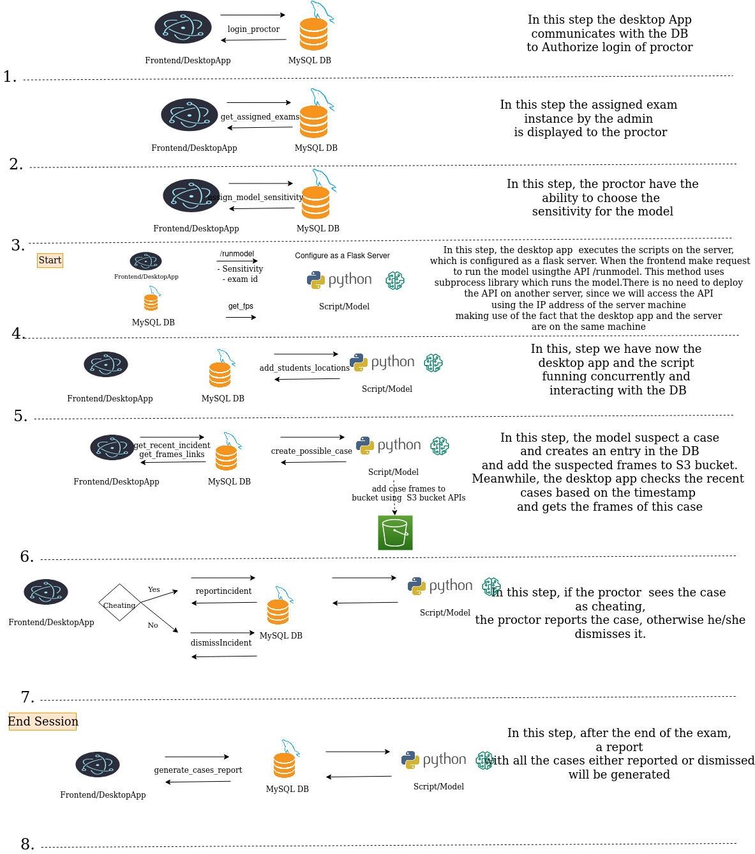

* **Data Design:**

This section of the software design document will contain an overview of management of

of the data that will be stored in a database and also the management of the data that does not need to be stored in the database.

* 4.1 Database Management System Files

For the design of the database we used MySQL and deployed the database of EC2 server. The rationale behind choosing MySQL for our database is that we have a well-defined schema and database design. For the privileges part, permissions are granted according to the two levels of privileges in RDBMS, which are account level or relation level. The account level, as well as the relation level privileges, is assigned by the DBA, Database administrator/s which have central authority for managing the database, i.e system account. The DBA will be responsible for granting or revoking privileges to individual accounts, users, or user groups and for performing certain actions.

* 4.2 Non-Database Management System Files

In our system, we capture videos and feed live it to the developed software. The extracted frames are transferred from the deep learning model to the backend of the system using AWS S3 bucket.

**Detailed Design:**

* 5.1 Hardware Detailed Design :

The system mainly consists of the IP camera that is positioned in the center of the classroom to capture the classroom top view to have a good view of the classroom environment. The IP camera should have a minimum of 4MP resolution in order to capture the movement and object details in a classroom setting. The IP camera also should have a suitable range of a minimum of 8 meters in order to capture a classroom of average dimensions of 8*6 meters.

* 5.2 Software Detailed Design:
* Frontend Development:

We have mainly 7 pages: Landing page, Main page, Login page, Confirmation page, Model Sensitivity page, End of Exam report and finally User Logout page. We used different technologies to try and make the application user friendly such as, HTML, CSS, Javascript and Bootstraps. We used a framework called ElectronJS as it is proven to generate desktop applications with better performance than other frameworks. The generated application operates on Windows, Linux, and macOS.

* Backend:

The backend of the system is designed using Flask framework which is python based framework. For the design of the database, we used MySQL and deployed the database of EC2 server. The rationale behind choosing MySQL for our database is that we have a well-defined schema and database design. Our APIs are mainly divided into two categories: Admin Level APIs and User Level APIs. The admin-level APIs are mainly used by the system owner/administrator in order to perform important functions.

* Deep Learning Model:

This is a two-step process. The frames are first checked by media pipe to measure the distance between nose and shoulder and if the distance is found smaller than a specific threshold then the student is looking at one of their sides then it is a suspected cheating case. Else, the frames go through the deep learning model implemented using YOLO.

The following diagram shows the functionality of the deep learning model:

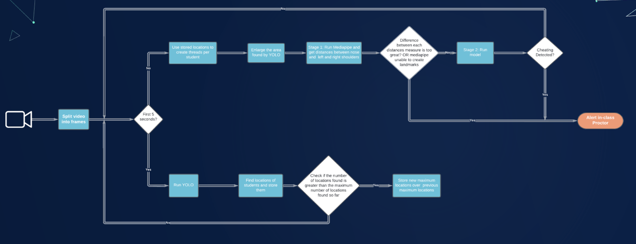

* 5.3 Communication Detailed Design: 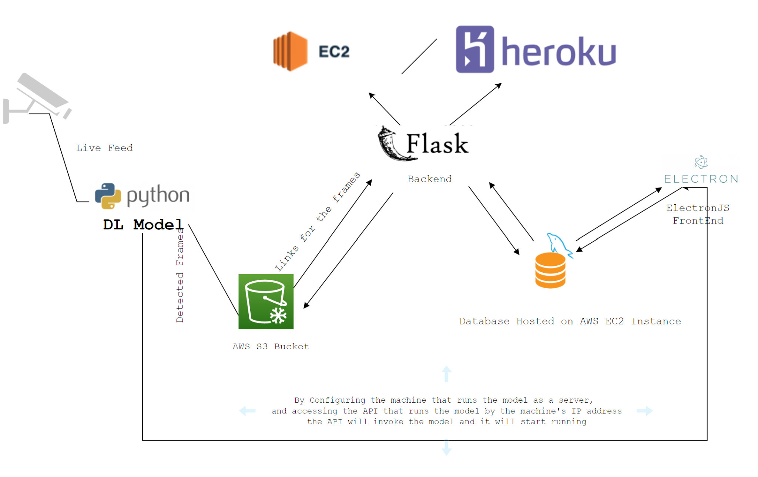

**Interfacing with External Systems:**

→ Graphical User Interface: An interface that eases the usage of the software for teachers and staff recruited by the ministry of education to deal with the software.

→ Cables and ports: as mentioned above the output of the IP camera should be fed to the software modules. This is done by connecting the camera to the computer machine that contains the developed software using Cat5 Ethernet cable.

* **Usability Design Approach:**

The front end of the system consists of 7 interfaces, in addition to the admin panel. The interfaces include the following:

1. Software Landing Page
2. Proctor Login Page
3. Exam Session Details Confirmation Page
4. AI Model Sensitivty Page
5. Home Page
6. End of Exam Report Page
7. Log out Page

* Software Landing Page



2- Proctor Login Page

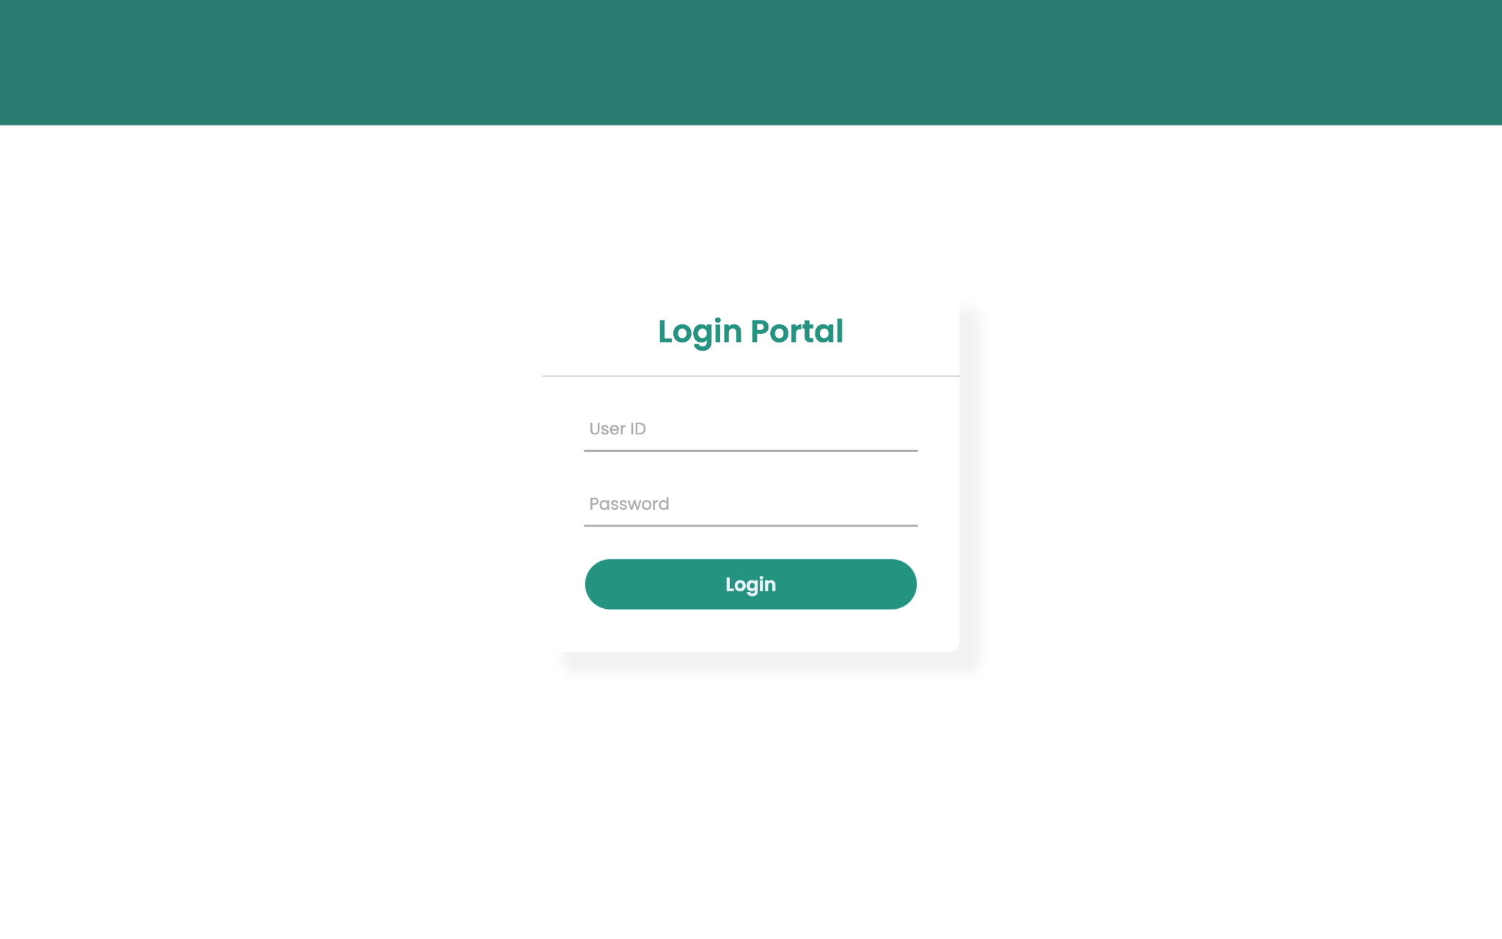

2- Exam Session Details Confirmation Page

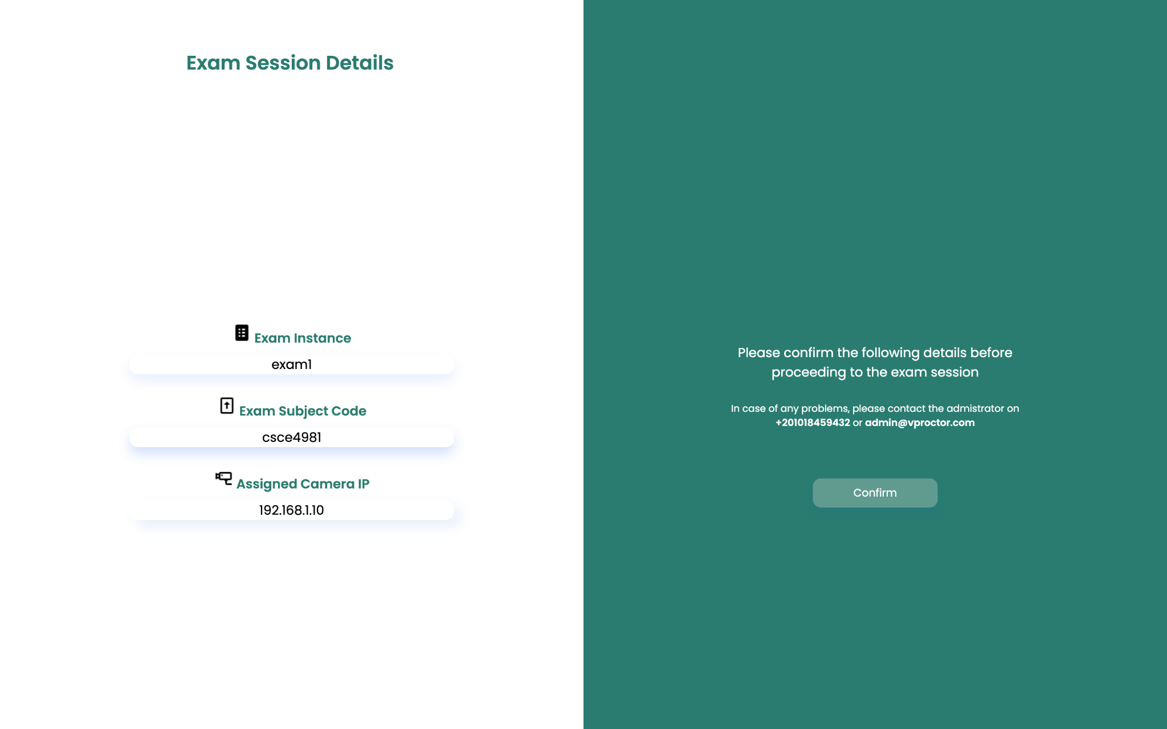

4- AI Model Sensitivity Page

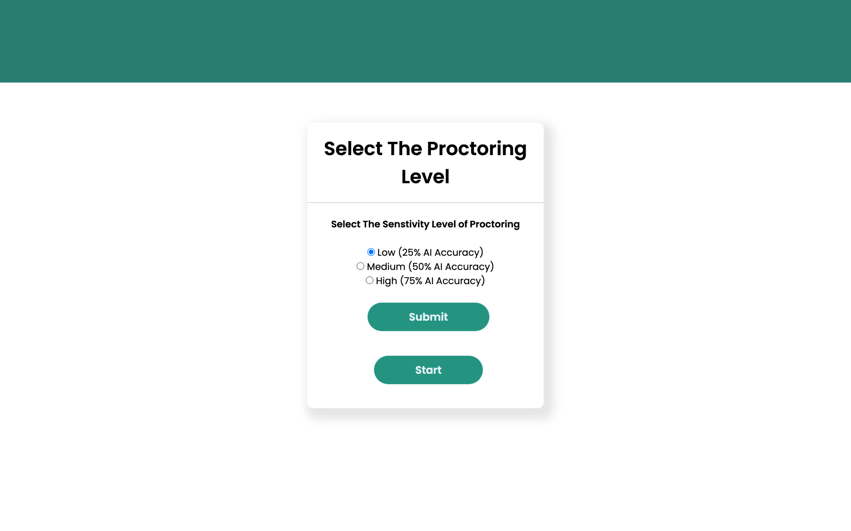

5- End of Exam Report Page:

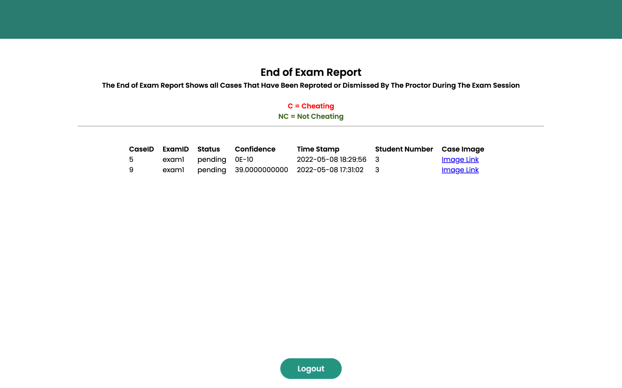

**Glossary of Terms**

* RDBMS: Relational Database Management System
* YOLO: You Only Look Once Object Detection Tool
* FPS: Frames Per Second
* DBA: Database Administrator
* RCNN: Region-Based Convolutional Neural Network
* CNN: Convolutional Neural Network